Model: Q2AM-CAM-4G-2.0MP
2.0 MP1080P 4G IP Camera
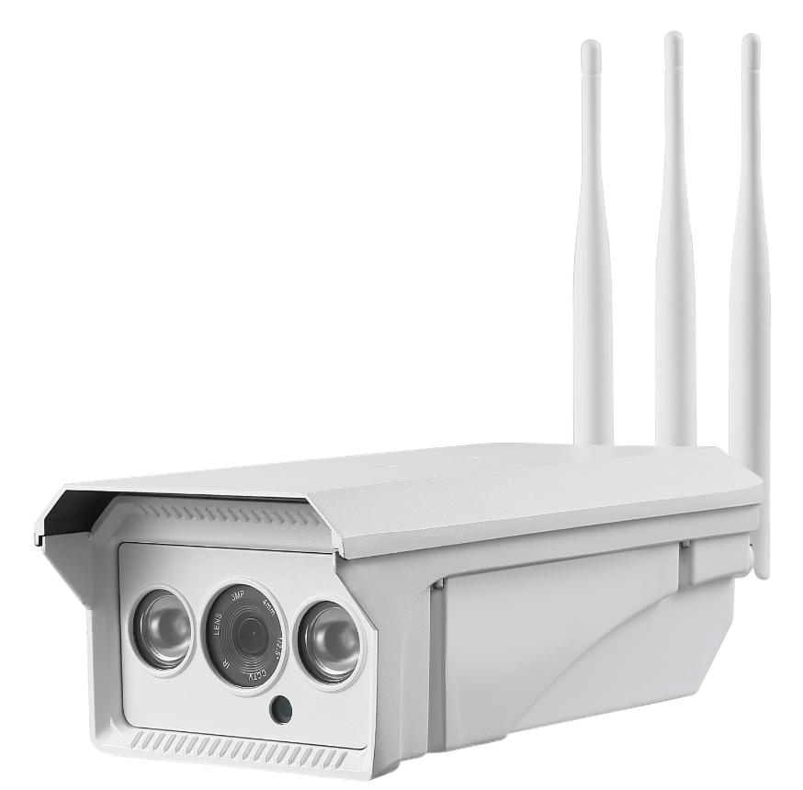

Camera Features:
- 1/2.9"2.0 Mega Pixels Sony IMX323 CMOS sensor
- HD resolution 1920 x 1080P
- Motion detection, email alert, FTP upload
- Built-in IR Cut,No Color Cast.
- P2P, PNP: Plug&play, Support QR code scanning to view on Iphone and andriod Mobiles
- Support SIM Card,3G/4G.
- TF Card:Max to 128GB
- Water-proofhousing, IP66
- 2pcs IR Leds, IR distance 20-60 meters
- 2.7-13.5 mm Motorized lens
- Power Consumption: Day <2W,Night:<6W
- P2P APP:CamHi
- PC Software: P2P Client
- Audio:Two Ways.
Technical Specifications:
Model | Q2A-CAM-4G-2.0MP
Camera
Image Sensor | 1/2.9"2.0 Mega pixels Sony IMX323CMOS
Chipset | Hi3516CV200+ IMX323
Effective Pixels | 1920(H)×1080 (V)
Video Resolution | 1080P@25/30fps
Electronic Shutter | AUTO, 1/25 -1/50,000s, FLK, 1-30x
Min. Illumination | 0.005Lux@F1.2(AGC ON), 0Lux IR on
Video | 2 ways audio
Day/Night | Auto/Color/(B/W)/EXT
Lens | 2.7-13.5mm Motorized Lens
USIM Card | 3G 4G Micro SIM Card
TF Card | Up to 128GB
IR Led | 2pcs IR Leds
IR Distance | 20-60M
Power Supply | 12 VDC ± 10%
Power Consumption | Day<1W, Night<3W
Operating Temp. | -20℃-(+60)℃, 10%-90%RH

